12. React-JS HOL

Name:- Shubham Sangram Bej

Hands-on 12

Objective
- Understand Conditional Rendering in React.
- Implement Login and Logout functionality.
- Render different components based on user authentication.
- Use React State to control component rendering.
- Demonstrate the use of Element Variables.

Software Requirements
- Node.js
- npm
- React
- Visual Studio Code

Project Name
ticketbookingapp

Procedure
- Created a new React application named ticketbookingapp.
- Created the following functional components:
  - UserGreeting
  - GuestGreeting
  - Greeting
  - LoginButton
  - LogoutButton
- Used a class component as the main application component.
- Initialized the application state using isLoggedIn = false.
- Implemented Login functionality to display the user page.
- Implemented Logout functionality to display the guest page.
- Used conditional rendering to switch between UserGreeting and GuestGreeting components.
- Used an element variable to render the appropriate Login or Logout button.
- Executed the application using:
npm start
- Verified the output by logging in and logging out.

Output
Initially, the application displays Please Sign Up with a Login button. After clicking “Login”, the page changes to Welcome Back, with a “Logout” button. Clicking “Logout” returns to the guest page.
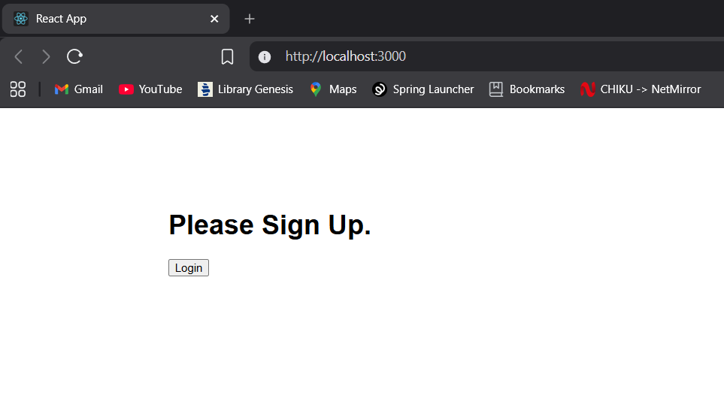

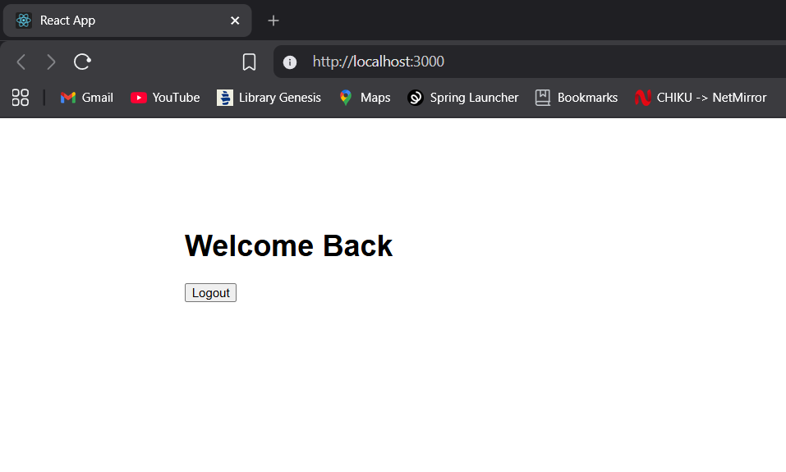

Result
The React application ticketbookingapp was successfully developed to demonstrate conditional rendering using React State and Element Variables.

